Prepared by:
Md. Ehasan Mahmud
Roll: 202122104026
Department: Computer Science and Engineering
Submitted to:
Dr. Sujan Chandra Roy
Lecturer
Department of Computer Science and Engineering
Bangabandhu Sheikh Mujibur Rahman University, Kishoreganj.
Course Title: Data Structure and Algorithms-II Lab
Course Code: CSE 2202
Assignment - 01
1.Implement the adjacency matrix of a given graph:
Code:
#include<bits/stdc++.h>
using namespace std;
vector<int>adj[100];
int main()
{
int n,e;
cin>>n>>e;
int arr[n+1][n+1];
for(int i=1;i<=n;i++){
for(int j=1;j<=n;j++){
arr[i][j]=0;
}
}
while(e--){
int u,v,w;
cin>>u>>v>>w;
adj[u].push_back(v);
adj[v].push_back(u);
arr[u][v]=w;
arr[v][u]=w;
}
cout<<endl;
/*cout<<"Adjacent Matrix are below: "<<endl;
for(int i=1;i<=n;i++){
for(int j=1;j<=n;j++){
cout<<arr[i][j]<<" ";
}
cout<<endl;
} */
cout<<endl;
int m;
cout<<"Enter the value for which adj. we want to know: "<<endl;
cin>>m;
for(int i=0;i< adj[m].size();i++){
cout<<adj[m][i]<<" ";
}
cout<<endl;

}
/*
6 9
1 2 5
1 3 1
1 4 3
1 5 5
2 6 8
2 4 3
3 4 2
3 5 4
6 4 7
*/

Output:


2. Prim's algorithm:
#include<bits/stdc++.h>
#define infinite 10e9
#define maxx 10
using namespace std;
int Graph[maxx][maxx]={
{0, 19, 8},
{21, 0, 13},
{15, 18, 0}
};
int DD[maxx][maxx],n;
int prims();
int main(){
int i,j,cost;
n=3;
cost=prims();
cout <<"Minimum Spanning Tree:";
for(i=0;i<n;i++) {
cout<<endl;
for(j=0;j<n;j++)
cout<<DD[i][j]<<" ";
}
cout<<endl;
cout<<" Minimum cost= "<<cost;
return 0;
}
int prims(){
int C[maxx][maxx];
int u,v,min_d,dist[maxx],from[maxx];
int visited[maxx],ne,i,min_c,j;
for(i=0;i<n;i++)
for(j=0;j<n;j++) {
if(Graph[i][j]==0)
C[i][j]=infinite;
else
C[i][j]=Graph[i][j];
DD[i][j]=0;
}
dist[0]=0;
visited[0]=1;
for(i=1;i<n;i++) {
dist[i]=C[0][i];
from[i]=0;
visited[i]=0;
}
min_c=0;
ne=n-1;
while(ne>0) {
min_d=infinite;
for(i=1;i<n;i++)
if(visited[i]==0&&dist[i]< min_d) {
v = i;
min_d=dist[i];
}
u=from[v];
DD[u][v]=dist[v];
DD[v][u]=dist[v];
ne--;
visited[v]=1;
for(i=1;i<n;i++)
if(visited[i]==0 && C[i][v]<dist[i]) {
dist[i]=C[i][v];
from[i]=v;
}
min_c=min_c+C[u][v];
}
return(min_c);
}
Output:
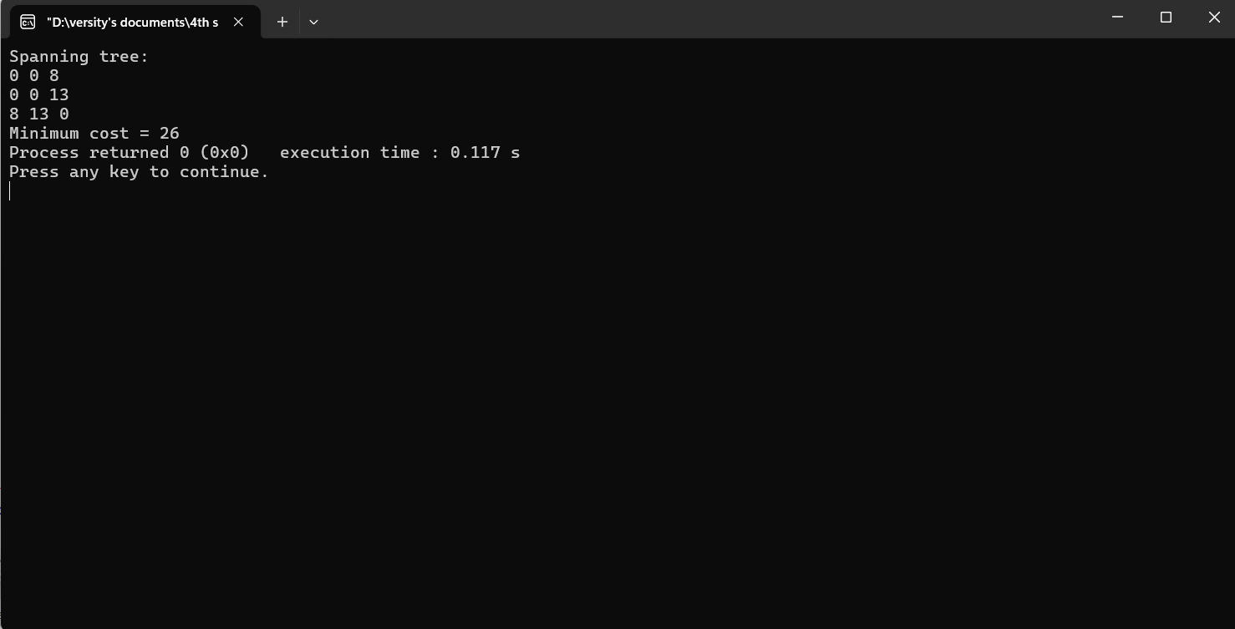

3. Kruskal's algorithm :
#include <bits/stdc++.h>
using namespace std;
const int inf=1e9;
int k,a,b,u,v,n,ne=1;
int mincost=0;
int cost[3][3]={
{0, 10, 20},{12, 0, 15},{16, 18, 0}};
int p[9]={0};
int aFind(int i)
{
while (p[i]!=0) {
i=p[i];
}
return i;
}
int aUnion(int i,int j)
{
if (i!=j) {
p[j]=i;
return 1;
}
return 0;
}
int main()
{
n=3;
for (int i=0;i<n;i++) {
for (int j=0;j<n;j++) {
if (cost[i][j]==0) {
cost[i][j]=inf;
}
}
}
//cout <<"Minimum Spanning Tree:";
cout<<endl;
while (ne<n) {
int min_val=inf;
for (int i=0;i<n;i++) {
for (int j=0;
j<n;j++) {
if (cost[i][j]<min_val) {
min_val=cost[i][j];
a=u=i;
b=v=j;
}
}
}
u=aFind(u);
v=aFind(v);
if (aUnion(u, v)!=0) {
//cout <<a<<"->"<<b<<"\n";
mincost +=min_val;
}
cost[a][b]=cost[b][a]=999;
ne++;
}
cout <<"Minimum cost="<<mincost<<endl;
return 0;
}

Output:


4. Bellman-Ford:
#include<bits/stdc++.h>
using namespace std;
struct Edge
{
int source,dest,weight;
};
void Path(vector<int> const &parent,int v)
{
if (v<0)
return;
Path(parent,parent[v]);
cout <<v<<" ";
}
void Bell_f(vector<Edge> const &edges,int source,int N)
{
int E=edges.size();
vector<int>distance(N, INT_MAX);
distance[source]=0;
vector<int>parent(N,-1);
int u,v,w,k=N;
while(--k)
{
for(int j=0;j<E;j++)
{
u=edges[j].source,v=edges[j].dest;
w=edges[j].weight;

if(distance[u]!=INT_MAX && distance[u]+w<distance[v])
{
distance[v]=distance[u]+w;
parent[v]=u;
}
}
}
for (int i=0;i<E;i++)
{
u=edges[i].source,v=edges[i].dest;
w=edges[i].weight;

if(distance[u]!=INT_MAX && distance[u]+w<distance[v])
{
cout << "Negative Cycle Here.";
return;
}
}
for (int i=0;i<N;i++)
{
cout<<"Distance of vertex "<<i<<" from the source "
<<setw(2)<<distance[i]<<" .Path is [ ";
Path(parent,i);cout<<"]"<<'\n';
}
}
int main()
{
vector<Edge>edges=
{
{ 0, 1, 2 },{ 1, 3, 4 },{ 0, 3, 6 }
};
int N=5;
int source=0;
Bell_f(edges,source,N);
return 0;
}
output:
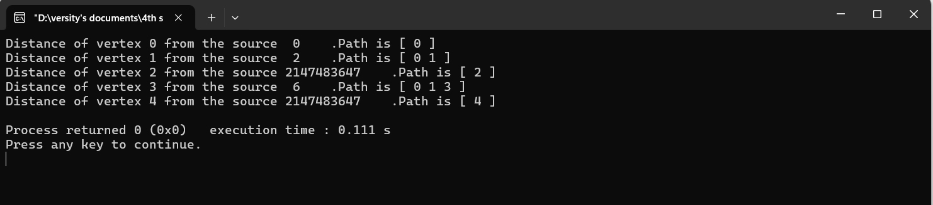

5. Dijkstra’s algorithm:
#include<bits/stdc++.h>
using namespace std;
int min_dist(int Dis[], bool Vis[]){
int Min=INT_MAX,id;
for(int k=0; k<6; k++) {
if(Vis[k]==false && Dis[k]<=Min) {
Min=Dis[k];
id=k;
}
}
return id;
}
void G_dij(int graph[6][6],int src){
int dist[6];
bool visited[6];
for(int k = 0; k<6; k++) {
dist[k] = INT_MAX;
visited[k] = false;
}
dist[src] = 0;
for(int k = 0; k<6; k++) {
int m=min_dist(dist,visited);
visited[m]=true;
for(int k = 0; k<6; k++) {
if(!visited[k] && graph[m][k] && dist[m]!=INT_MAX && dist[m]+graph[m][k]<dist[k])
dist[k]=dist[m]+graph[m][k];
}
}
cout<<"Vertex Distance from source"<<endl;
for(int k = 0; k<6; k++) {
char St=65+k;
cout<<St<<" "<<dist[k]<<endl;
}
}
int main(){
int graph[6][6]={
{0, 1, 2, 0, 0, 0},
{1, 0, 0, 5, 1, 0},
{2, 0, 0, 2, 3, 0},
{0, 5, 2, 0, 2, 2},
{0, 1, 3, 2, 0, 1},
{0, 0, 0, 2, 1, 0}
};
G_dij(graph,0);
return 0;
}
output: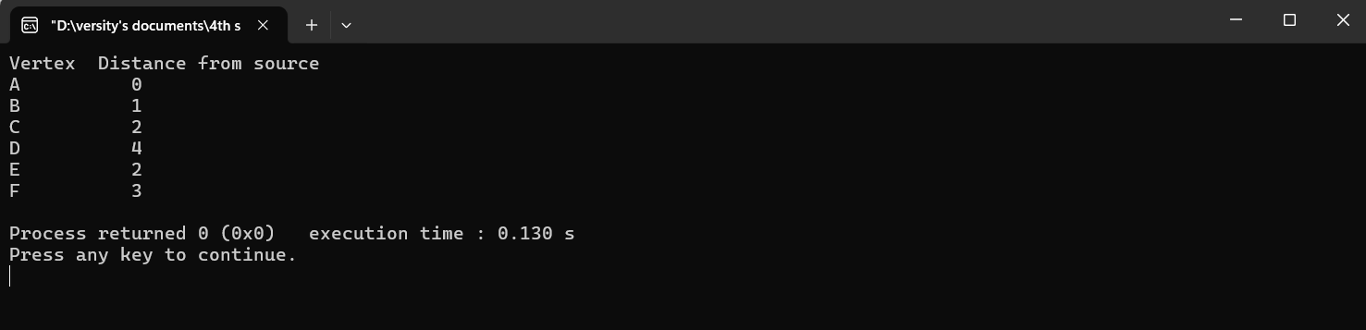

6. Floyd-Warshall algorithm:
#include <bits/stdc++.h>
using namespace std;
void FloydW(int b[][3]){
int i,j,k;
for (int k=0;k<3;k++) {
for (int i=0;i<3;i++) {
for (int j =0;j<3;j++) {
if ((b[i][k]*b[k][j]!=0) && (i!=j)) {
if ((b[i][k]+b[k][j]<b[i][j]) || (b[i][j]==0)) {
b[i][j]=b[i][k]+b[k][j];
}
}
}
}
}
for (i=0;i<3;i++) {
cout<<"Minimum Cost:"<<i<<endl;
for (j=0;j<3;j++) {
cout<<b[i][j]<<" ";
}
}
}
int main(){
int b[3][3];
for (int i=0;i<3;i++) {
for (int j=0;j<3;j++) {
b[i][j]=0;
}
}
b[0][1]=10;
b[1][2]=15;
b[2][0]=12;
FloydW(b);
return 0;
}
output:
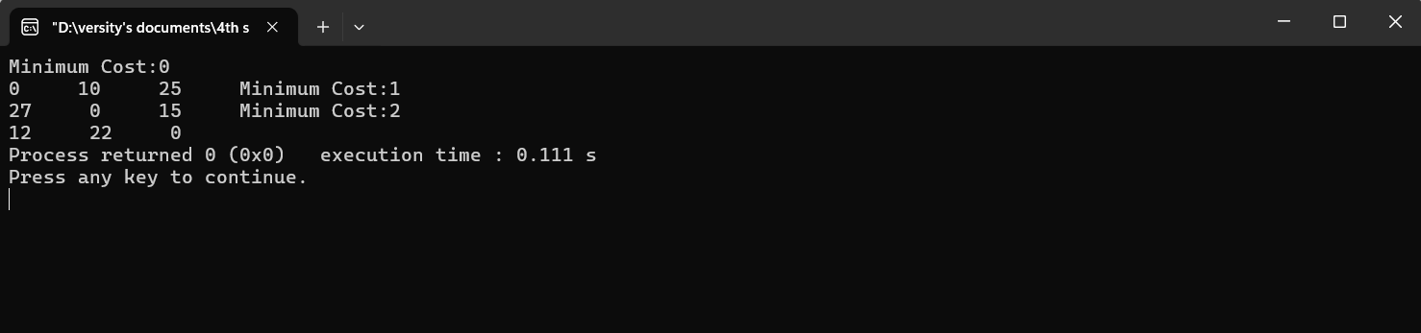

7. Johnson’s algorithm :
#include<bits/stdc++.h>
#define int long long
using namespace std;
const int INF=1e18;
const int NN=500;
vector<pair<int,int>>G[NN];
vector<int>Bell_f(int N,vector<vector<int>>&edges){
vector<int>r(N+1,INF);
r[0]=0;
for(int i=0;i<=N;i++){
bool check=false;
for(auto&e:edges){
int u=e[0],v=e[1],w=e[2];
if(r[u]!=INF&&r[v]>r[u]+w){
r[v]=r[u]+w;
check=true;
}
}
if(!check)break;
}
return r;
}
void Dijk(int src,vector<vector<int>>&path,int N){
priority_queue<pair<int,int>,vector<pair<int,int>>,greater<pair<int,int>>>pq;
vector<int>dist(N+1,INF);
dist[src]=0;
pq.push({0,src});
while(!pq.empty()){
int d=pq.top().first,u=pq.top().second;
pq.pop();
if(d>dist[u])continue;
for(auto&[v,w]:G[u]){
if(dist[u]+w<dist[v]){
dist[v]=dist[u]+w;
pq.push({dist[v],v});
}
}
}
path[src]=dist;
}
signed main(){
int N,M;
cin>>N>>M;
vector<vector<int>>edges;
for(int i=0;i<M;i++){
int u,v,w;
cin>>u>>v>>w;
edges.push_back({u,v,w});
}
for(int i=1;i<=N;i++){
edges.push_back({0,i,0});
}
vector<int>C=Bell_f(N,edges);
for(auto&e:edges){
e[2]+=(C[e[0]]-C[e[1]]);
}
for(auto&e:edges){
if(e[0]!=0){
G[e[0]].push_back({e[1],e[2]});
}
}
vector<vector<int>>path(N+1,vector<int>(N+1,INF));
for(int i=1;i<=N;i++){
Dijk(i,path,N);
}
for(int i=1;i<=N;i++){
for(int j=1;j<=N;j++){
if(path[i][j]==INF){
cout<<-1<<" ";
}else{
cout<<path[i][j]-(C[i]-C[j])<<" ";
}
}
cout<<endl;
}
return 0;
}
/*
4 5
1 2 3
1 3 8
1 4 -4
2 4 7
3 2 4
*/
Output:
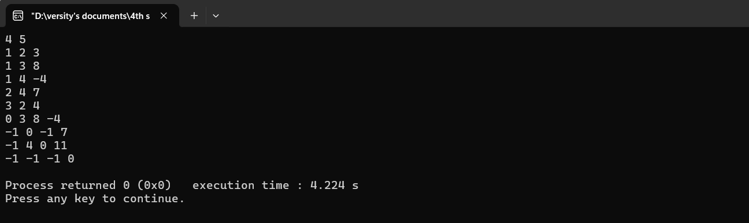

8. Ford-Fulkerson algorithm:
#include <bits/stdc++.h>
using namespace std;
int BFS(int Src,int target,int n,vector<int>& parent,vector<vector<int>>& graph){
fill(parent.begin(),parent.end(),-1);
parent[Src] = -2;
queue<pair<int,int>> q;
q.push({Src,1e9});
while(!q.empty()){
int u = q.front().first, cap = q.front().second;
q.pop();
for(int v=0;v<n;v++){
if(u!=v && graph[u][v]!=0 && parent[v]==-1){
parent[v] = u;
int min_cap = min(cap,graph[u][v]);
if(v==target)return min_cap;
q.push({v,min_cap});
}
}
}
return 0;
}
int f_Fulker(int source,int target,int n,vector<vector<int>>& graph){
vector<int> parent(n,-1);
int max_flow = 0,min_cap = 0;
while(min_cap = BFS(source,target,n,parent,graph)){
max_flow += min_cap;
int v = target;
while(v!=source){
int u = parent[v];
graph[u][v] -= min_cap;
graph[v][u] += min_cap;
v=u;
}
}
return max_flow;
}
void addEdge(vector<vector<int>>& graph,int u,int v,int w){
graph[u][v] = w;
}
int main(){
int V = 6;
vector<vector<int>> graph(V,vector<int>(V,0));
addEdge(graph,0,1,4);
addEdge(graph,0,3,3);
addEdge(graph,1,2,4);
addEdge(graph,2,3,3);
addEdge(graph,2,5,2);
addEdge(graph,3,4,6);
addEdge(graph,4,5,6);
cout << "Max Flow: " << f_Fulker(0,5,V,graph) << endl;
return 0;
}
output:

